React Native Expo Project
Progress Log
Student Name: ____Katellyn Hyker____________________________________
App Name: ______InnerBloom__________________________________

Progress Made

- Fixed navigation errors
- Planned and set up layout for habitTrackerScreen and addHabitScreen.
- Added Date functionality
- Completed Habit data structure
- Completed addHabit functionality
- Completed checkbox functionality
- Completed Habit Tracking navigation
Design Updates
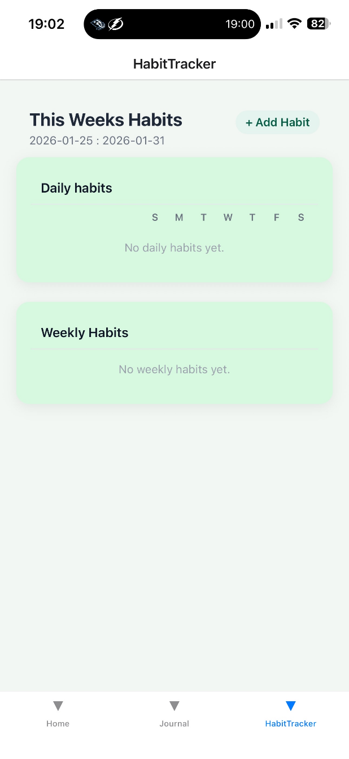
Include screenshots or images of your app screens below.
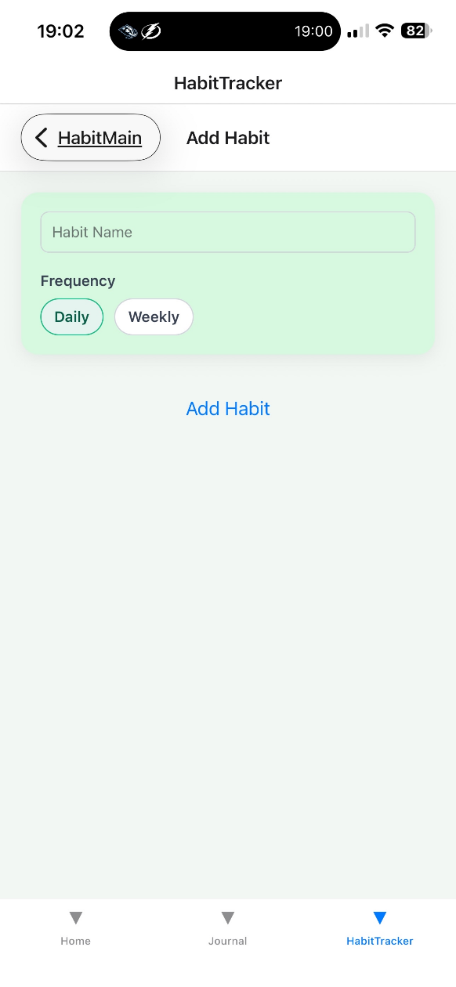
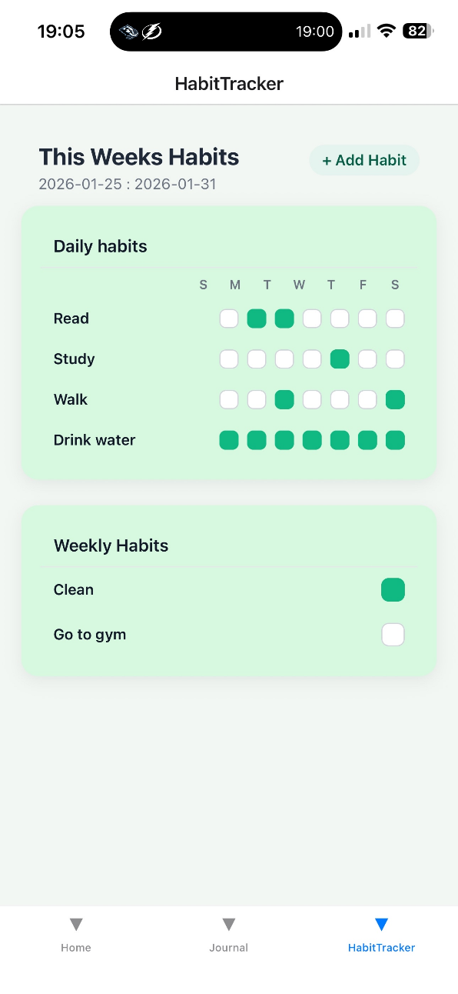
Issues / Blockers

No new issues.
Main blockers:
Uncertainty for additional homescreen feature
Uncertainty on direction for database
Trying to figure out what additional features could be added on time.
Next Steps

List what needs to be finished
Finish homescreen functionality
Consider which features may be reasonable to add in the timeline

